ID issue after conversion from V4.2 to 5.0.1 on november 22nd 2018

Id generated for prescriptions is overwriting old data. Below difference in order by date_added and id
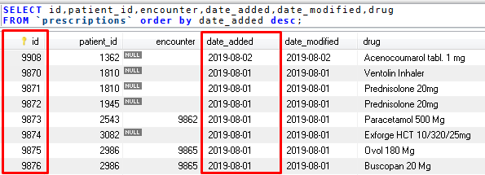
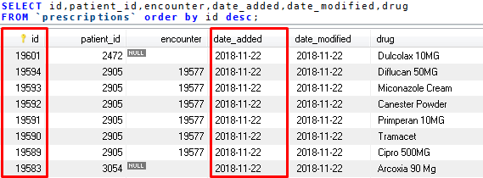
Prescriptions are added via a “replace into” statement causing the existing id’s to be overwritten.
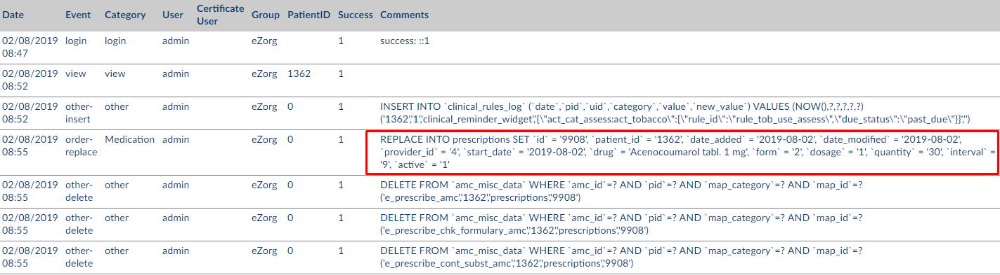

The tableform_encounters gets the next number from the same sequence as prescriptions.
