Upload ERAs to OpenEMR

Download ERAs from Office Ally:
1. In Office Ally’s left navigation bar, click "Download EOB / ERA 835"
2. This displays a calendar and a list of the current day's ERAs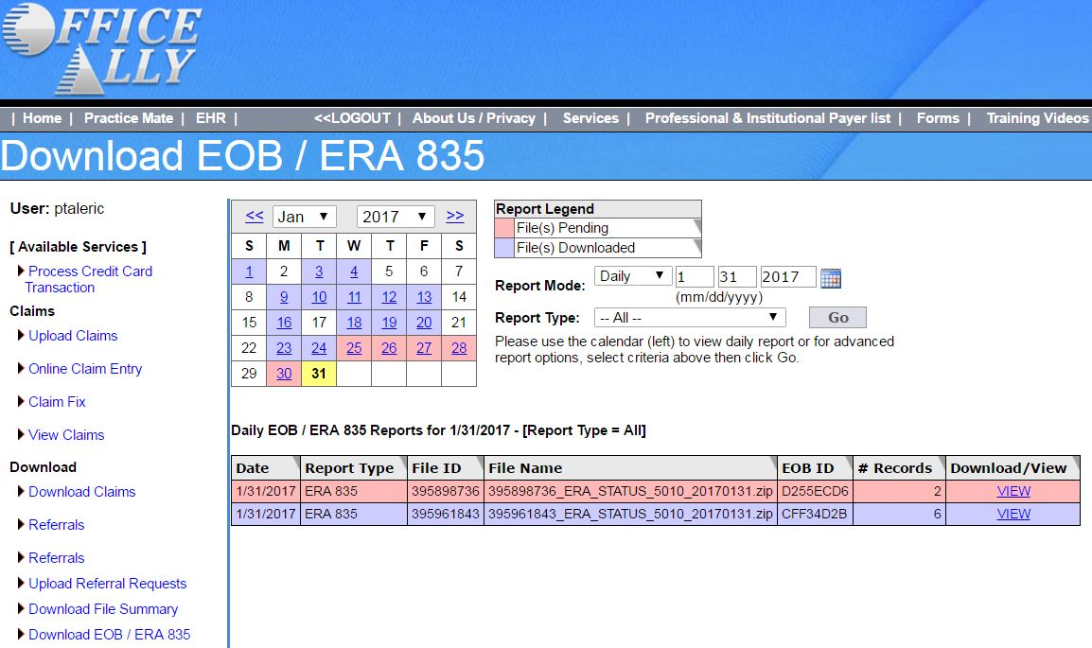
3. Find the ERA you are looking for on the list and click the blue "VIEW" link.
4. This downloads a .zip file to your browser's Downloads folder
5. Open the .zip file and extract the 2 files that it contains: one is a .835 file and the other is a .txt file.
6. Open the .txt file:
1. To identify the Payer for the ERA (see step 5, below)
Palmetto GBA is Medicare
2. To review each line item to see if there are any denials (see step 11, below)

Upload the ERAs to OpenEMR:
1. In OpenEMR's left navigation bar, click Fees: Batch Payments
2. Click on the "ERA Posting" tab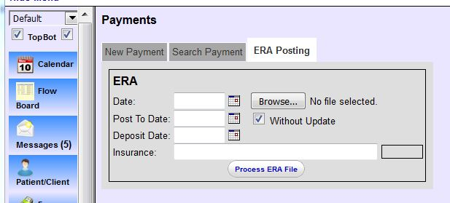
3. Click the "Browse" button
4. Select the .835 file you just unzipped
5. In the Insurance field, enter the Payer for the ERA that was identified in the .txt file
6. Uncheck "Without Update" box if checked (If left checked, the payments for this ERA will not post to the patients' accounts)
7. Click "Process ERA file"
1. If a warning like this pops up, it means this ERA has already been uploaded. (Even though the error states "was already uploaded and processed," it may or may not have actually been processed (posted) to the patient's account).
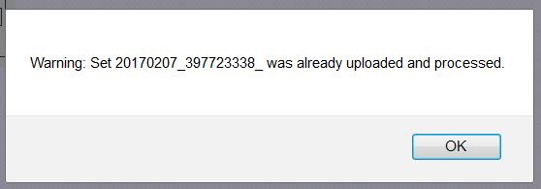
2. We therefore don't want to move on to step 8. Click OK, and close the tab and move on to the next ERA needing processing.
8. This will bring up a checkbox list of the check numbers associated with this ERA: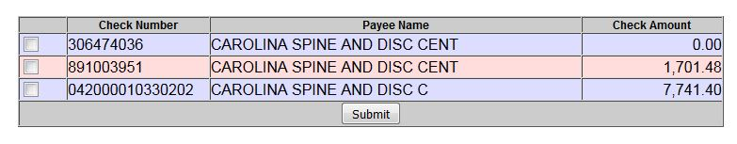
9. Check all checkboxes, even those with $0 check amount, then click "Submit"
10. A new browser tab appears displaying the newly-posted transactions: (Close this tab after you have reviewed it).